

# Computer & Electronic Engineering

# Final Year Project "Music Host Interface"

# Sprint 7: Week 3 Log

# Thomas Flynn

# Project Supervisor: Brian O'Shea

# 28/03/16 - 03/04/16

# 1 Log Entries

## 1.1.0 Entry 1: 28/03/16

Today I worked on setting up boolean options for android. I also planned out how to implement the communication interface.

## 1.2.0 Entry 2: 29/03/16

Today I continued working on bool options for android as well as adding the bool options to the FX GUI. I also worked interfacing bool options between client and server.

## 1.3.0 Entry 3: 30/03/16

Today I worked on implementing the observable listView for my selection and queue list. I also continued working on bool options for android

## 1.4.0 Entry 4: 31/03/16

Today I continued work on the observable list in my javaFX GUI. I also added end of media listeners as well as anchoring my players to a mediaView object.

## 1.5.0 Entry 5: 01/04/16

Today I reviewed my server and client code in relation to UUID. I then spent most of today reworking my existing server code to run an executor fixed thread pool. Now the android user has 30 seconds to make a decision before the server thread dies and starts waiting for a new connection.

## 1.6.0 Entry 6: 02/04/16

Today I embarked on what proved to be one of the most challenging aspects of my project. I wanted to remove the mediaPlayer attached to my QueueSong object and also remove the maximum allowed number of mediaplayers to 3.

## 1.7.0 Entry 7: 03/04/16

Today I nearly gave up on this song queue sequence as it seemed overwhelmingly complex for my current programming skills along with the looming deadline. But with perseverance and a few coffee breaks with pen and paper to figure out exactly what the requirements were proved to be the solution. I am very proud of this achievement because now only 3 song files exist in my destination folder at any given time.

# 2 Task completed:

Set up bluetooth communication interface.

Android option buttons enabled by first msg from server.

FX bool buttons disable/enable.

Add song function adds a single song.

Initialize button populates selection list alone.

Song foreign keys working with logged in user.

Only songs of logged in user appear in selection list.

Song object deletes it's own file when removed from queue.

User can add selected song from selection.

Song request feature working mostly.

Executor bluetooth connection thread working.

Server times out after 30 seconds.

Song queue object no longer holds mediaPlayer object.

Song queue only has 3 mediaPlayer objects at a time.

# 3 GIT Repositories:

## 3.1-FYP-Android

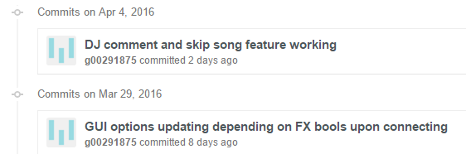

## 3.2-FYP-GUI

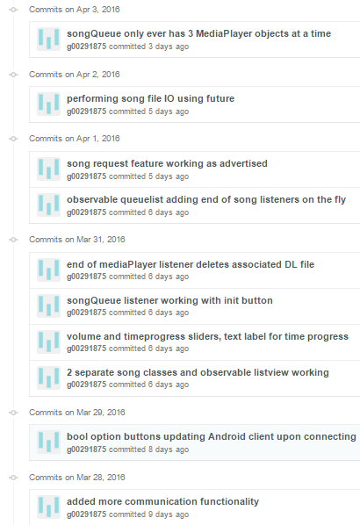

# 4 Trello boards

## 4.1 Board at the start of the week:

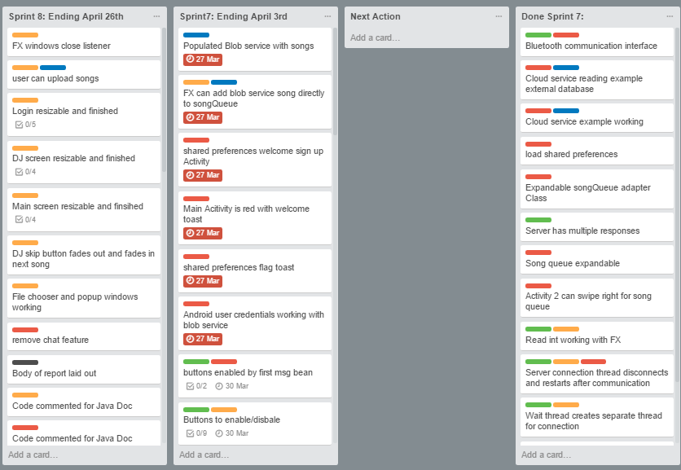

## 4.2 Board at the end of the week:

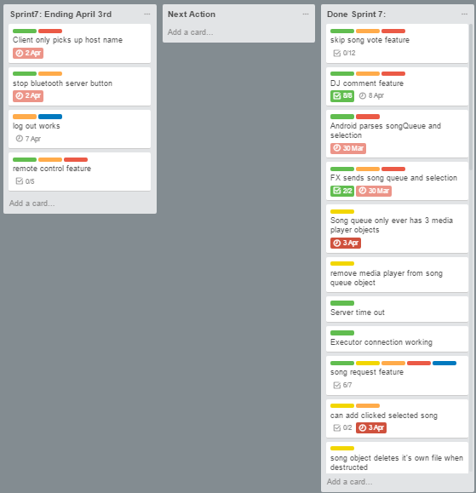

# 5 Toggl Time Logs

## 5.1 Weekly time Log bar chart:

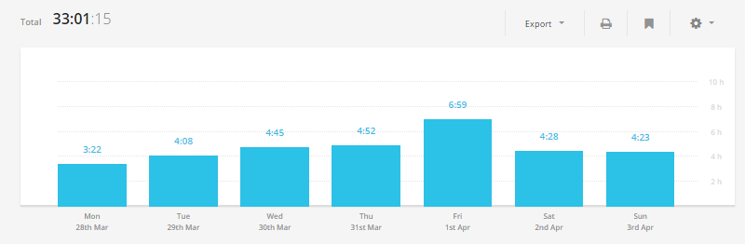

## 5.2 Weekly Time Log:

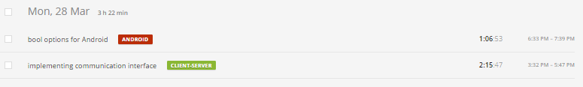

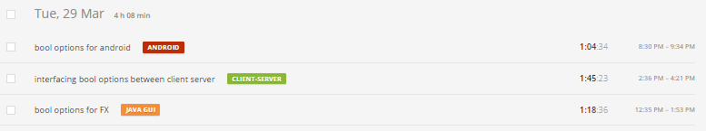

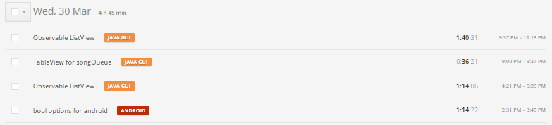

## C:\year 5\Project Year 5 Documentation\Weekly screenshots\Sprint 7\wk3\4.PNG

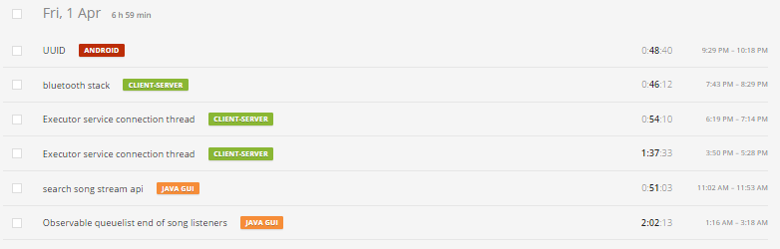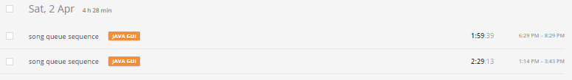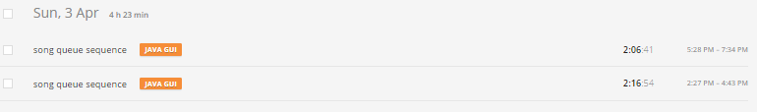

## 5.3Weekly log Pie Charts:

